ROSSMOYNE SENIOR HIGH SCHOOL


Yr11/12 Semester Two Examination, 2012

Question/Answer Booklet

MATHEMATICS 2C/2D

Section One:

Calculator-free

Your name

Teacher’s name

Time allowed for this section
Reading time before commencing work: five minutes
Working time for this section: fifty minutes

Materials required/recommended for this section

To be provided by the supervisor
This Question/Answer Booklet
Formula Sheet

To be provided by the candidate
Standard items: pens, pencils, pencil sharpener, eraser, correction fluid/tape, ruler, highlighters

Special items: nil

Important note to candidates

No other items may be used in this section of the examination. It is your responsibility to ensure that you do not have any unauthorised notes or other items of a non-personal nature in the examination room. If you have any unauthorised material with you, hand it to the supervisor before reading any further.

Structure of this paper

Section | Number of questions available | Number of questions to be answered | Working time (minutes) | Marks available | Percentage of exam
Section One:  Calculator-free | 7 | 7 | 50 | 50 | 33
Section Two:  Calculator-assumed | 12 | 12 | 100 | 100 | 67
 |  |  | Total | 150 | 100

Instructions to candidates

- The rules for the conduct of Western Australian external examinations are detailed in the Year 12 Information Handbook 2012. Sitting this examination implies that you agree to abide by these rules.

- Write your answers in the spaces provided in this Question/Answer Booklet. Spare pages are included at the end of this booklet. They can be used for planning your responses and/or as additional space if required to continue an answer.
- Planning: If you use the spare pages for planning, indicate this clearly at the top of the page.
- Continuing an answer: If you need to use the space to continue an answer, indicate in the original answer space where the answer is continued, i.e. give the page number. Fill in the number of the question(s) that you are continuing to answer at the top of the page.

- Show all your working clearly. Your working should be in sufficient detail to allow your answers to be checked readily and for marks to be awarded for reasoning. Incorrect answers given without supporting reasoning cannot be allocated any marks. For any question or part question worth more than two marks, valid working or justification is required to receive full marks. If you repeat an answer to any question, ensure that you cancel the answer you do not wish to have marked.

- It is recommended that you do not use pencil, except in diagrams.

Section One: Calculator-free (50 Marks)
This section has seven (7) questions. Answer all questions. Write your answers in the spaces provided.

Working time for this section is 50 minutes.

Question 1 (7 marks)
(a) Simplify the expression 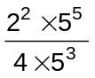. (2 marks)

(b) Find 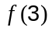 if 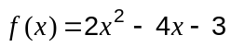. (1 mark)

(c) Factorise
(i) 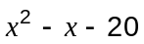. (1 mark)

(ii) 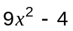. (1 mark)

(d) Solve the equation 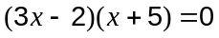 (2 marks)

Question 2 (7 marks)
The coordinates of four points are A(2, -1), B(1, 2), C(0, 5) and D(4, 8).

(a) Determine the gradient of the Line 1, which passes through A and B. (2 marks)

(b) Line 2 passes through point C and has a gradient of 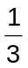.
Write down the equation of this line. (1 mark)

(c) Explain whether Line 1 and Line 2 are parallel, perpendicular or neither. (2 marks)

(d) Calculate the distance between points C and D, if one unit is one centimetre. (2 marks)

Question 3 (8 marks)
In a random survey of 100 swimmers at a council owned pool, three-quarters said they swam regularly. 35 males said they swam regularly and 10 more males than females were surveyed.

(a) If one of the swimmers surveyed was chosen at random, what is the probability that they did not swim regularly? (1 mark)

(b) Complete this two-way table using the above information. (3 marks)

 | Swam regularly | Did not swim regularly | Total
Female
Male
Total

(c) If one of those surveyed said they did not swim regularly, are they more likely to be female or male? Justify your answer. (2 marks)

(d) If only 25 swimmers had been surveyed, how many of these would you expect to be males who say that they swam regularly? (2 marks)

Question 4 (9 marks)
(a) The graph of 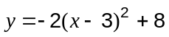 is drawn below.
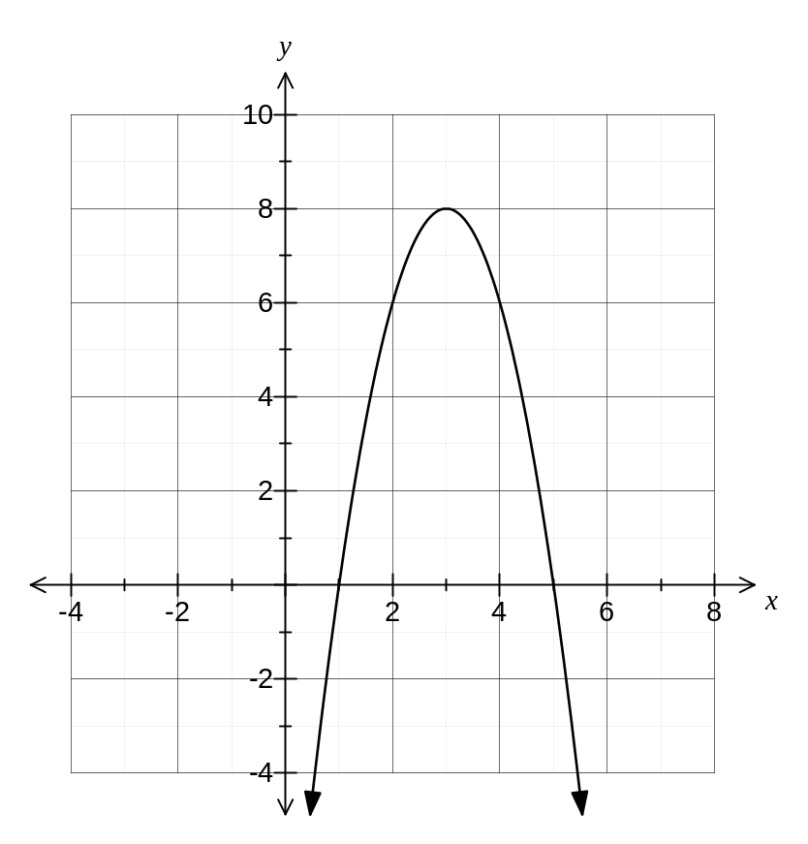
For this graph, determine

(i) the equation of the line of symmetry (1 mark)

(ii) the coordinates of the turning point (1 mark)

(iii) the coordinates of the y-intercept (1 mark)

(iv) the equation of the graph in the form 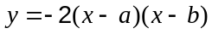, where and are integers. (1 mark)

(b) Draw the graph of 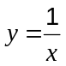 on the axes below. (3 marks)
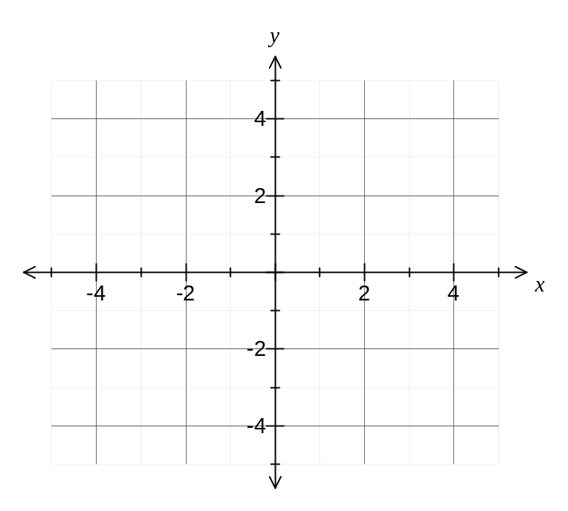

(c) Two of the functions 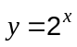 , 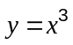 and 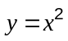 were used to create Table A and Table B below. On the line below each table, write the function used. (2 marks)

 | 0 | 1 | 2 |  |  | 0 | 1 | 2
 | 0 | 1 | 8 |  |  | 1 | 2 | 4
Table A |  |  |  |  | Table B

Question 5 (7 marks)
A class sat two tests and the scores of the students in each are shown below.

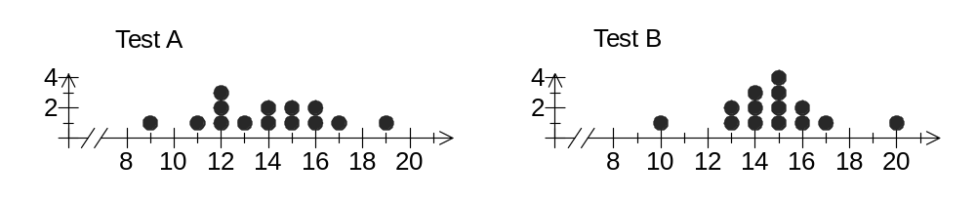

(a) The mean score was 13.9 for Test A. Is the mean of scores in Test B larger than, smaller than, or equal to 13.9? Explain your answer. (2 marks)

(b) What is the range of scores in Test A? (1 mark)

(c) The standard deviation of scores in Test A was 2.18. Is the standard deviation of scores in Test B larger than, smaller than, or equal to 2.18? Explain your answer. (2 marks)

(d) Which is the better measure to compare the spread of scores in these two tests - the range or the standard deviation? Justify your choice. (2 marks)

Question 6 (6 marks)
The graphs (A, B, C, D and E) and equations (P, Q, R, S and T) of five functions are shown below.
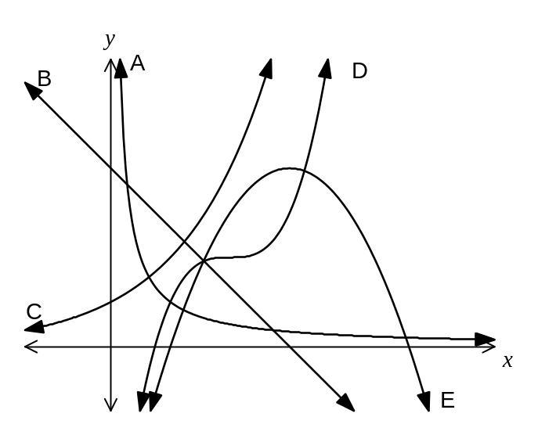 | P
 | Q | 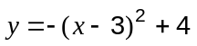
 | R
 | S | 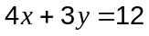
 | T | 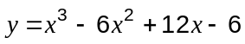

(a) Write down the letter of the graph which is an example of

(i) an exponential function (1 mark)

(ii) a cubic function (1 mark)

(b) Write down the letter of the equation which is an example of

(i) a quadratic function (1 mark)

(ii) a reciprocal function (1 mark)

(c) Give the coordinates of

(i) the y-intercept of the linear function (1 mark)

(ii) the turning point of the parabola (1 mark)

Question 7 (6 marks)
(a) Consider the statement that 'the sum of two consecutive odd counting numbers is always divisible by four'.

(i) Systematically check this statement with three examples. (2 marks)

(ii) Do your examples suggest that the statement is true or false? (1 mark)

(b) Consider the statement that 'the sum of three consecutive terms of the Fibonacci sequence(1,1,2,3….) is always a multiple of six'.

(i) Check this statement. (2 marks)

(ii) Is the statement true or false? (1 mark)

Additional working space

Question number: _________

This examination paper may be freely copied, or communicated on an intranet, for non-commercial purposes within educational institutes that have purchased the paper from WA Examination Papers provided that WA Examination Papers is acknowledged as the copyright owner. Teachers within purchasing schools may change the paper provided that WA Examination Paper's moral rights are not infringed.

Copying or communication for any other purposes can only be done within the terms of the Copyright Act or with prior written permission of WA Examination papers.

Published by WA Examination Papers
PO Box 445 Claremont WA 6910

